How to do when U2 cannot pop up the Setup to install automatically?
Problem: Plugged in the computer does not respond and cannot pop up automatically install the prompt. It cannot be found in network adapter but there is USB displayed at right corner of the computer.
Solution:
Method 1:In the control panel, select the view as a small icon.
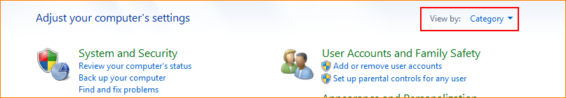
Find out ”AutoPlay”. Check ”Use AutoPlay for all media and devices”, and save it. Then plugged the card will pop up the running program automatically.
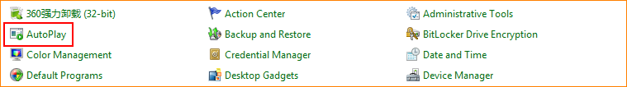
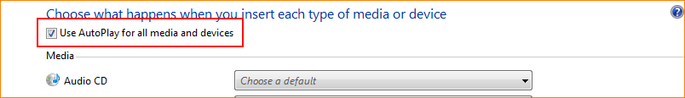
Method 2:If it can not automatically run the program, you can manually run the CD drive on “my computer” on desktop.
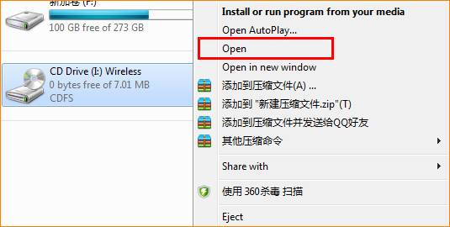
Method 3:If cannot find the CD drive, you can turn off anti-virus software, exit the firewall, or replace the USB interface to re-plug the card to install.

